**Coding and Solutioning**

**Team ID:** PNT2022TMID53169

**Team members:** Anirudh BS, Bhuvaneswar AS, Bhavesh N, Chirag Bheemaiah

PK

**Feature 1 –** Bring about awareness about Arrhythmia, its types and its consequences to the general public.

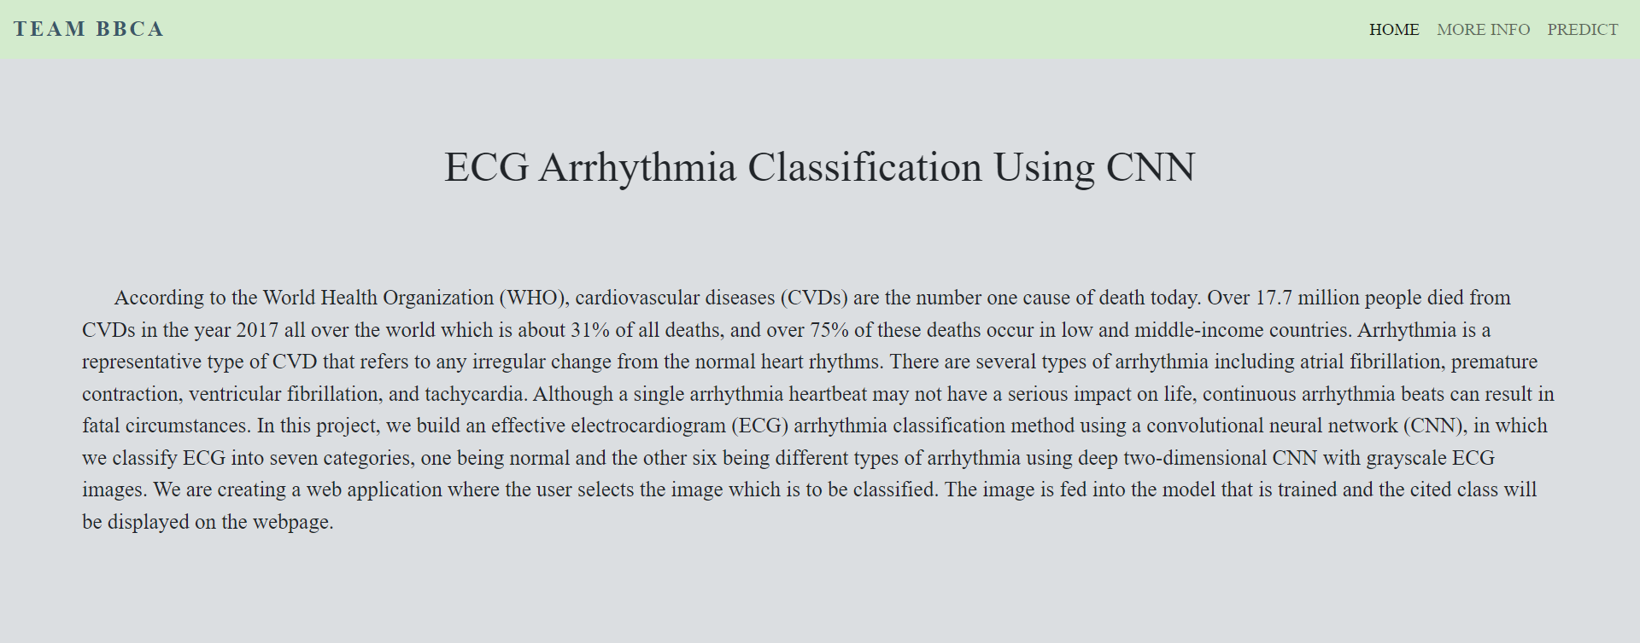

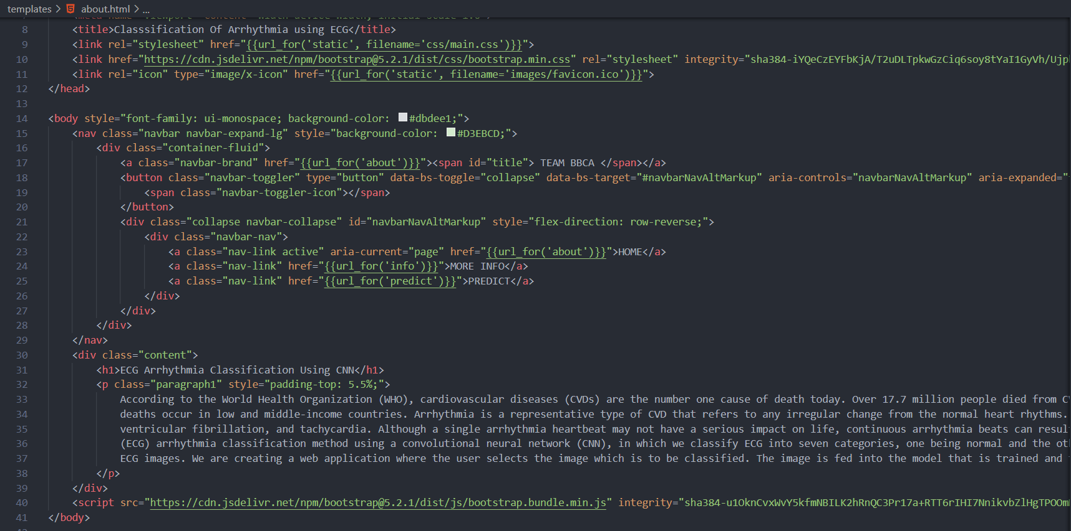

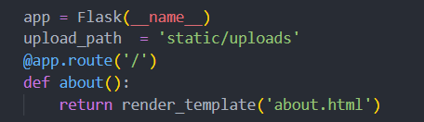

Using flask as the backend, the **‘/about’** URL is defined which renders a static webpage containing all the relevant information when requested by the user.

**Feature 2 –** Elaborate on all the medical jargon associated with Arrhythmia to help the patient properly understand the diagnosis

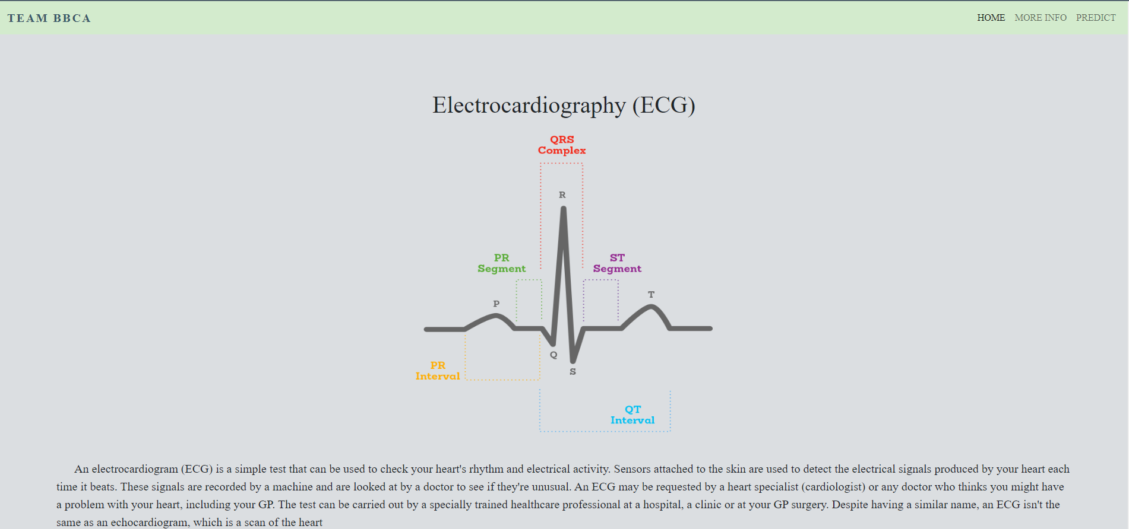

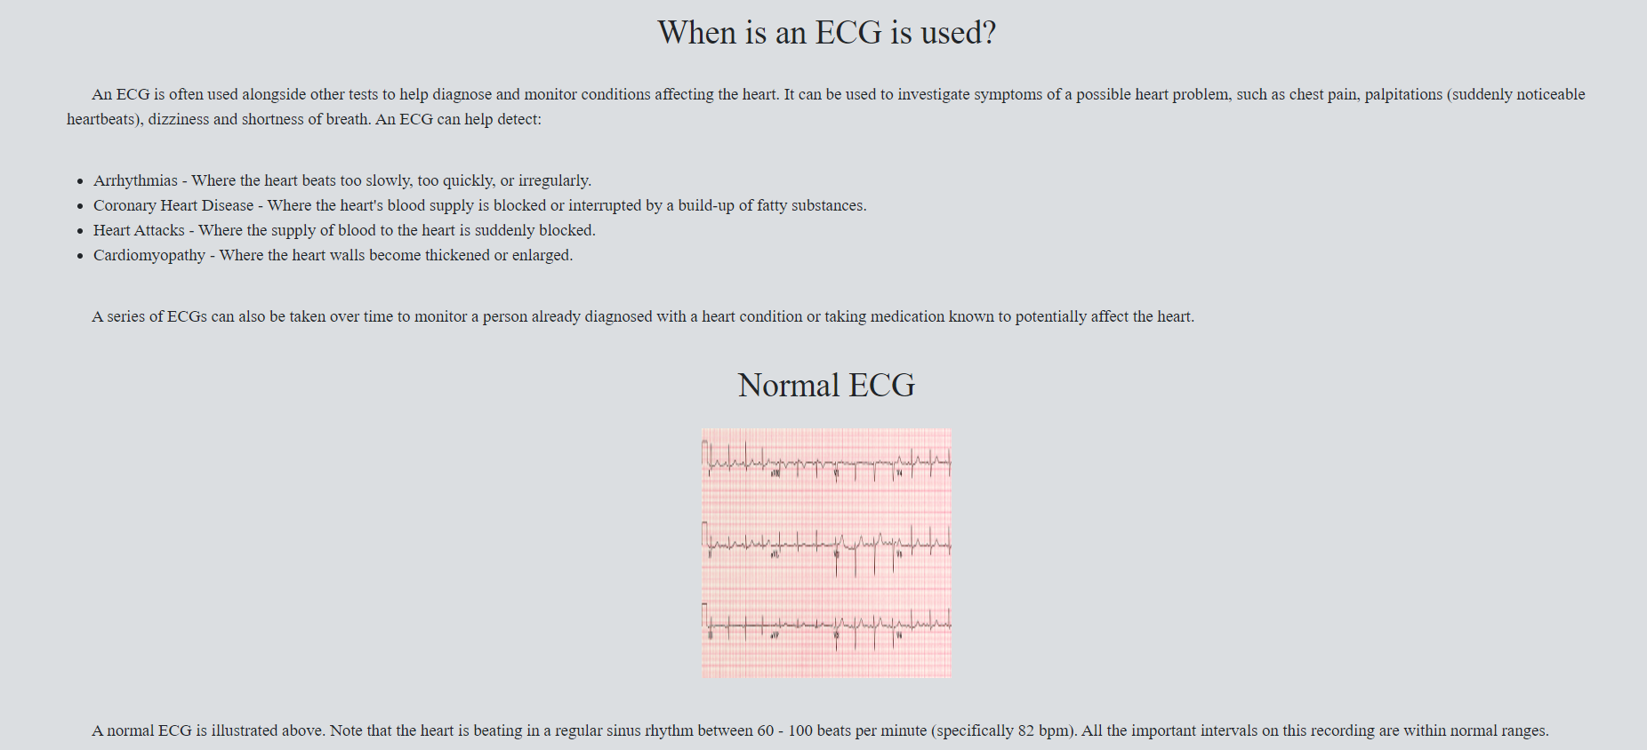

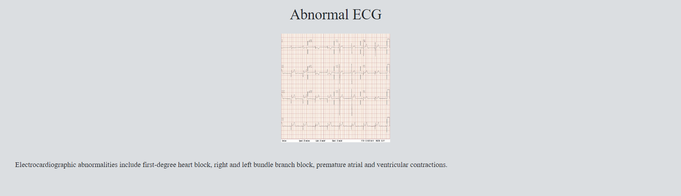

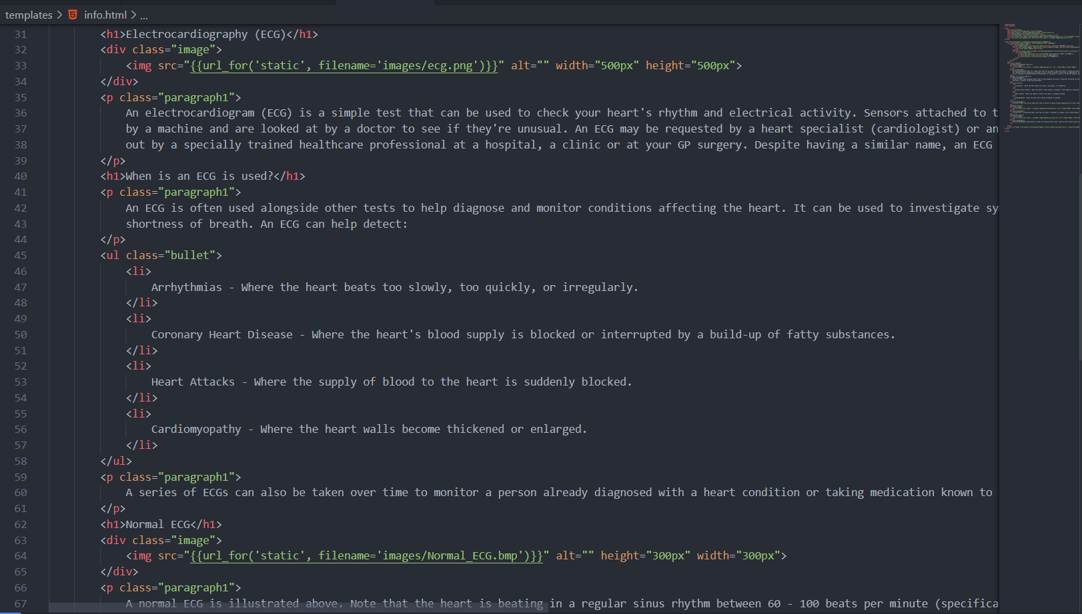

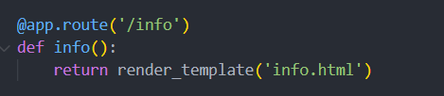

The **‘/info’** URL is defined which renders a static webpage containing all the relevant information when requested by the user. It uses Flask’s inbuilt ‘url-for’ method to handle multimedia.

**Feature 3 –** For accurate diagnosis, high quality dataset was obtained which represented the different classes proportionately and was used for the purposes of training, testing and validation. Image processing techniques were experimented with to extract maximum accuracy.





**Image Split:**

Left Bundle Branch Block – 504 images

Normal – 7436 images

Premature Atrial Contraction – 2054 images

Premature Ventricular Contractions – 2759 images

Right Bundle Branch Block – 2239 images

Ventricular Fibrillation – 439 images

For reducing skewness in the dataset, ImageDataGenerator class was used for both processing and handling with data imbalance.

**Feature 4 –**To ensure highest possible classification accuracy, state of the art algorithms such as Convolutional Neural Networks were trained over several epochs with varying hyperparameters to ascertain the best accuracy.

**Model Architecture:**

Model: "sequential"

_______________________________________________________

Layer (type) Output Shape Param #

=======================================================

conv2d (Conv2D) (None, 62, 62, 32) 896

max_pooling2d (MaxPooling2D) (None, 31, 31, 32)) 0

conv2d_1 (Conv2D) (None, 29, 29, 32) 9248

max_pooling2d_1 (MaxPooling2D) (None, 14, 14, 32) 0

flatten (Flatten) (None, 6272) 0

dense (Dense) (None, 32) 200736

dense_1 (Dense) (None, 6) 198

=======================================================

Total params: 211,078

Trainable params: 211,078

Non-trainable params: 0

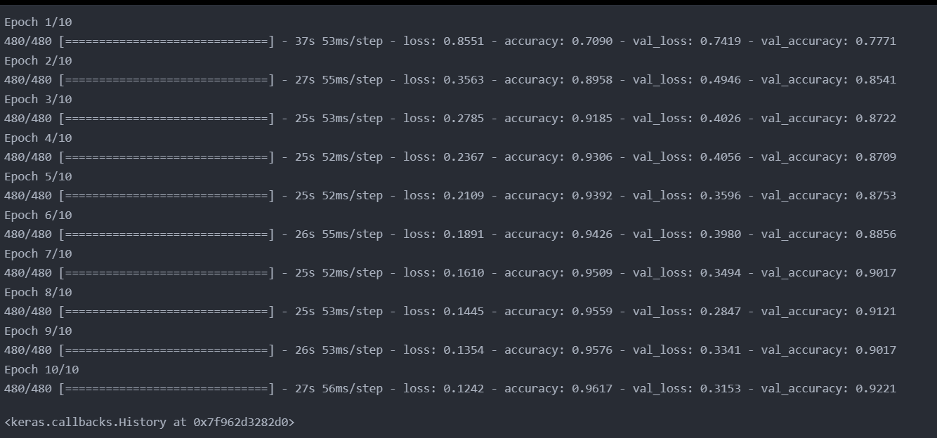

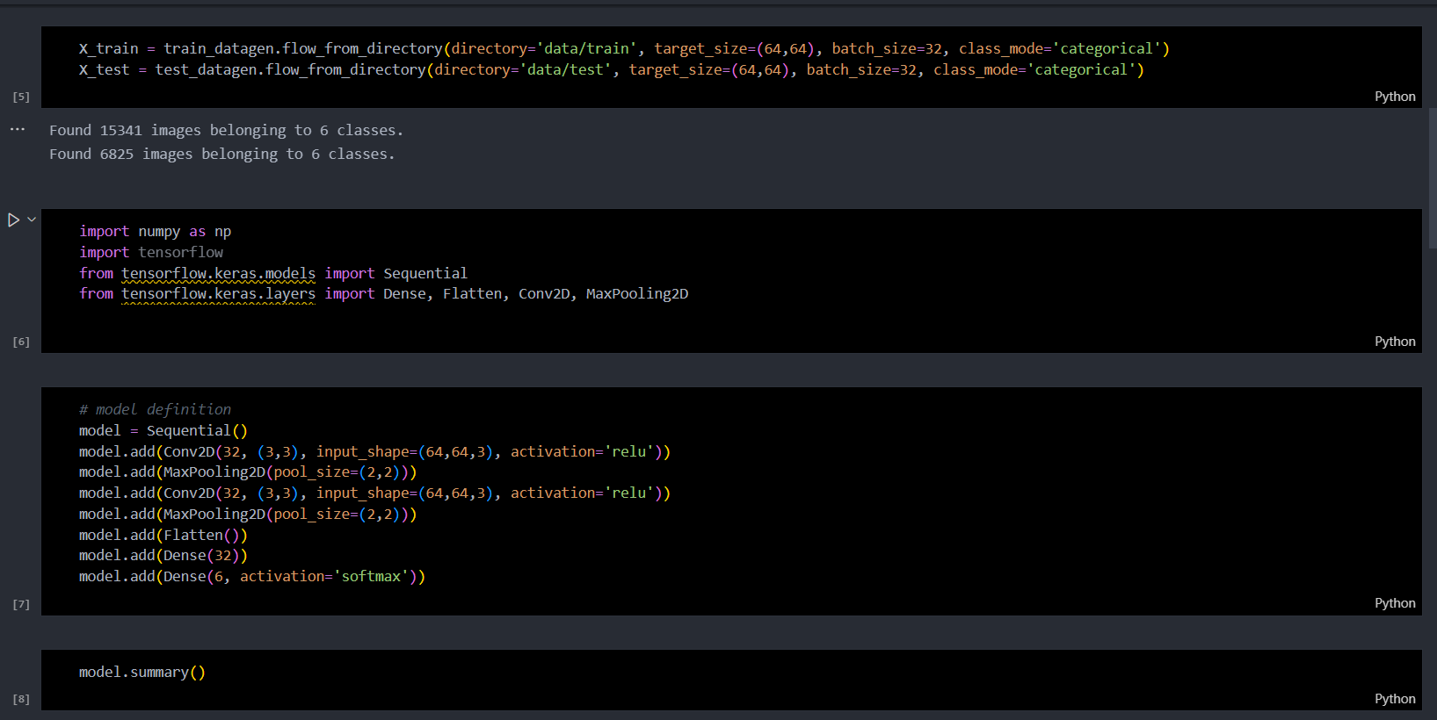

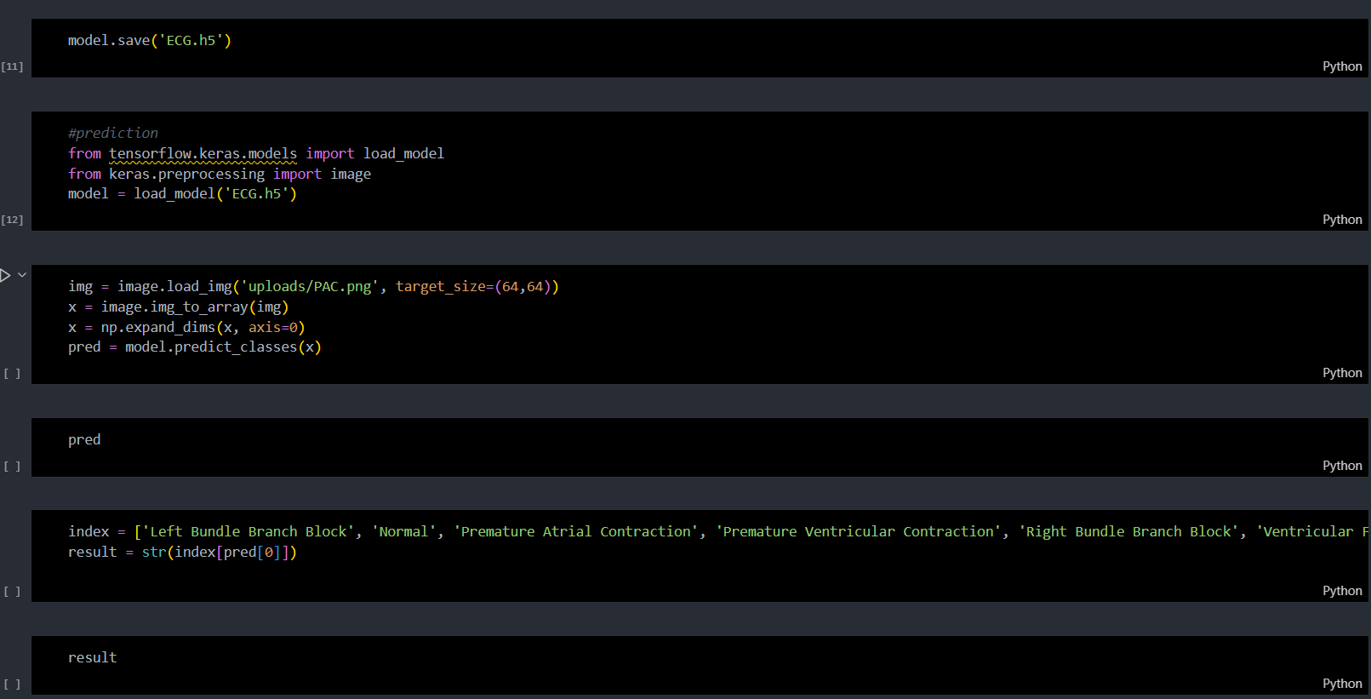

Using Jupyter Notebooks, different models were tested and the one with the best accuracy was chosen.

**Feature 5-**

Provide the users with the ability to upload the ECG image for prediction.

**Screenshot:**

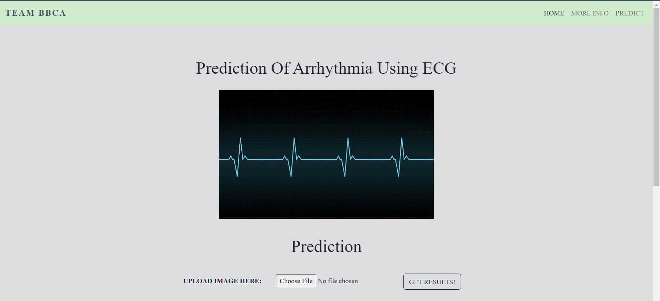

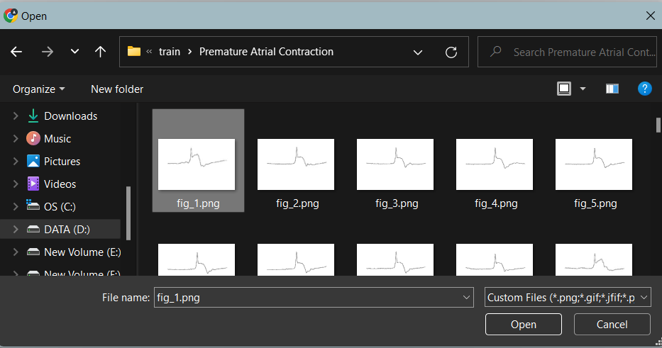

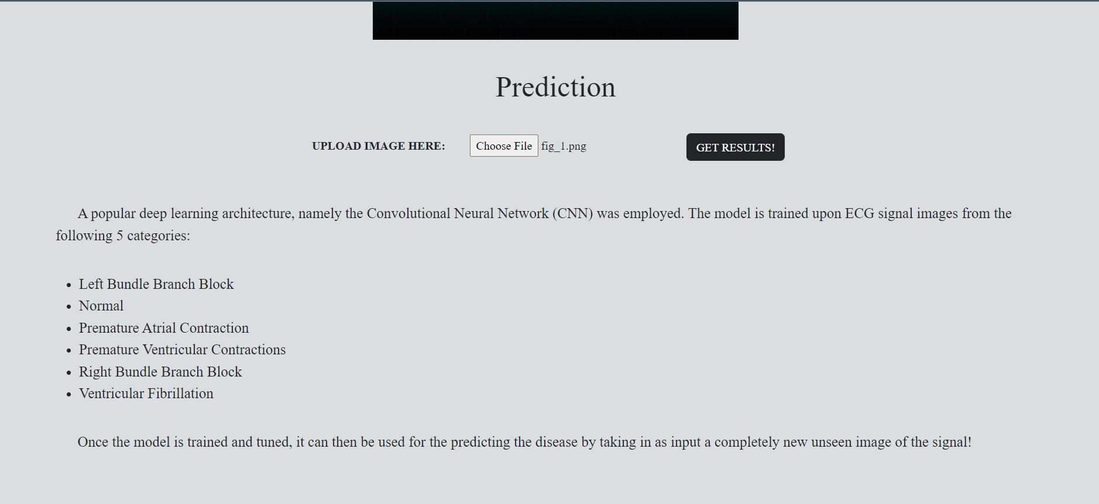

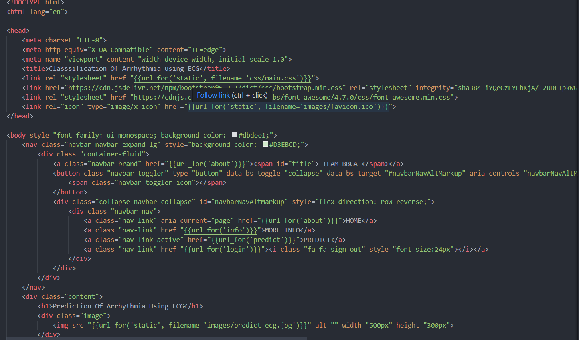

Using ‘**predict**’ URL the users can upload their image for results.

**Feature 6-**

Users must be able to view the results of the classification, should also receive additional information about the type of arrhythmia.

**Screenshot:** 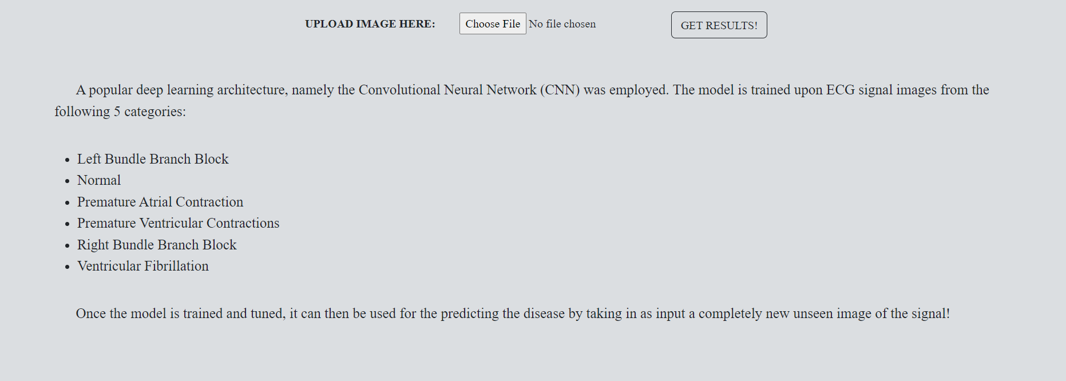

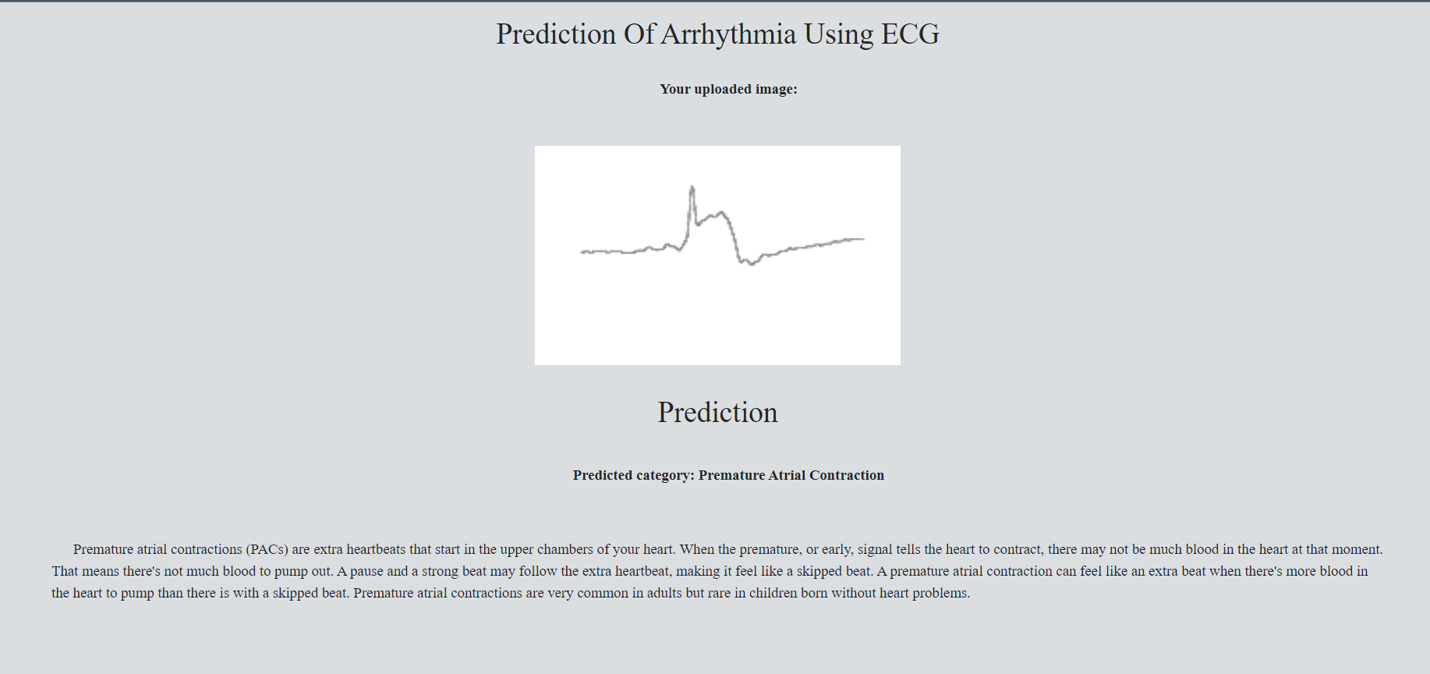

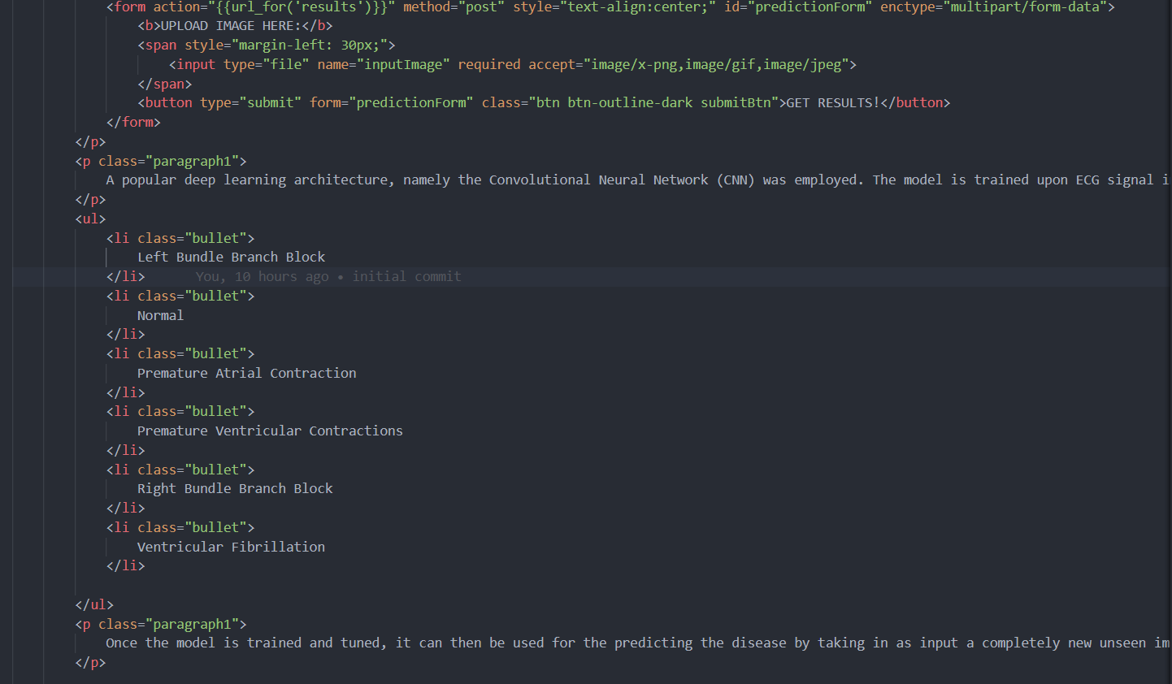

Using ‘Predict’ URL, we can see the prediction category.

**Feature 7-**

The user should be directed to further sources of help which would help in the treatment process.

**Screenshot:**



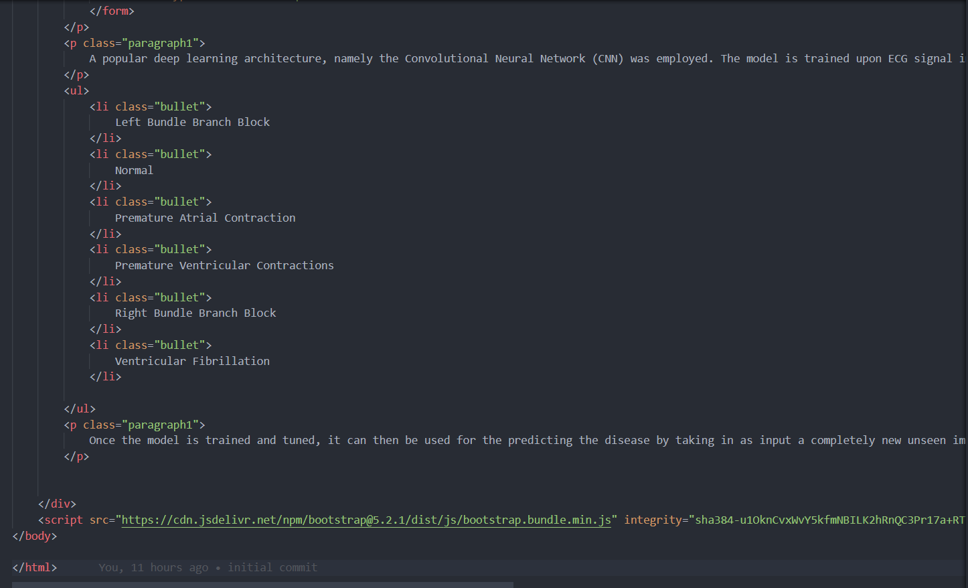

The prediction category will be shown with further information for help

**Feature 8-**

Users can log into the application by entering email & password

**Screenshot:** 

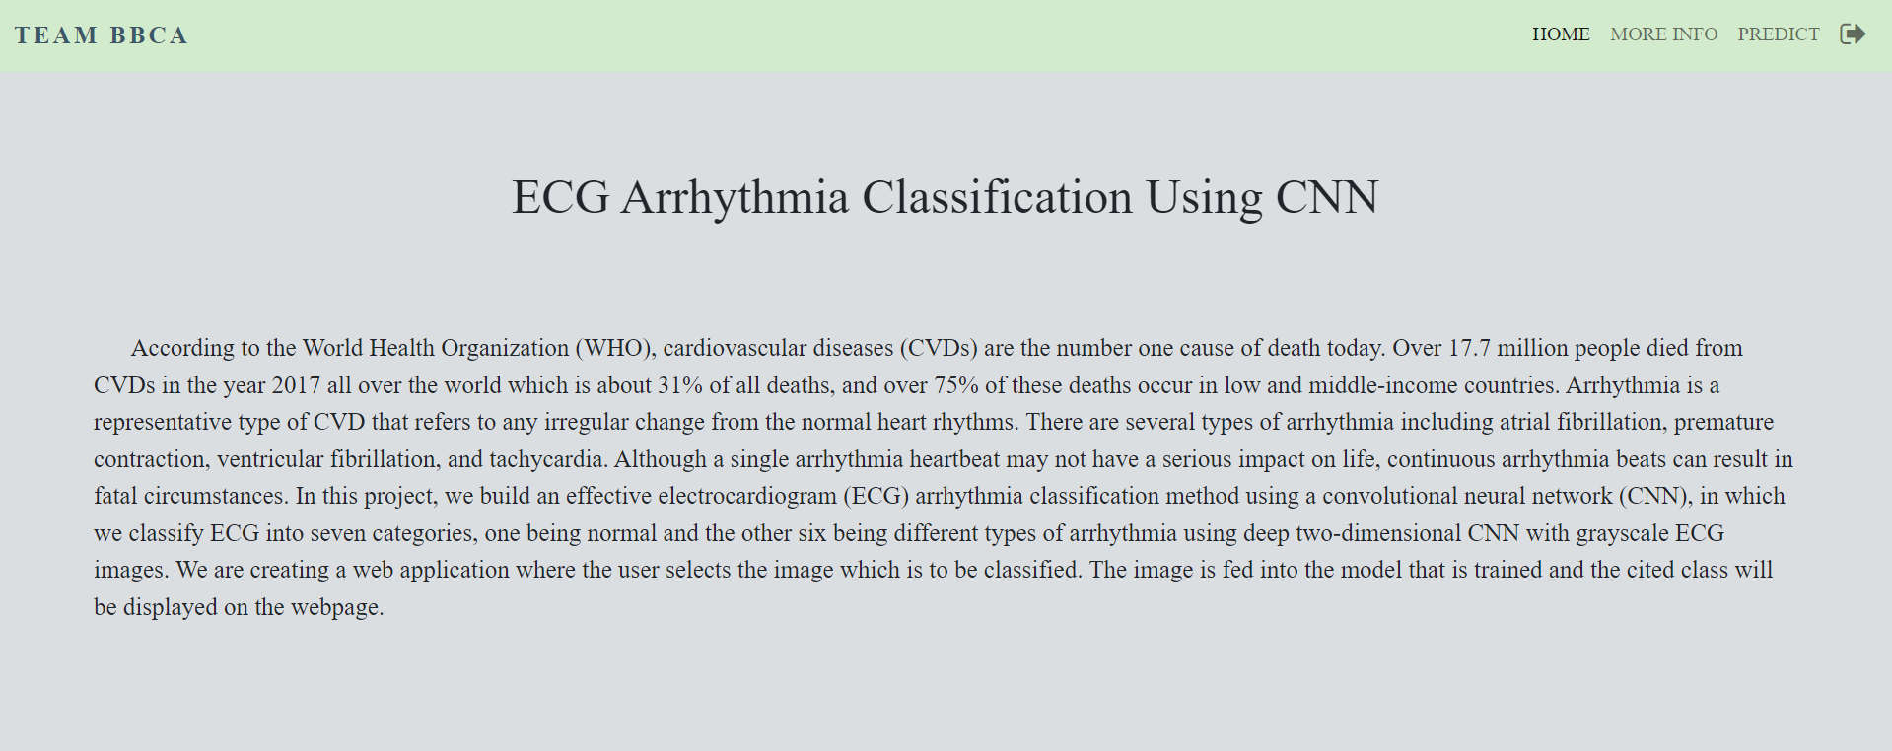

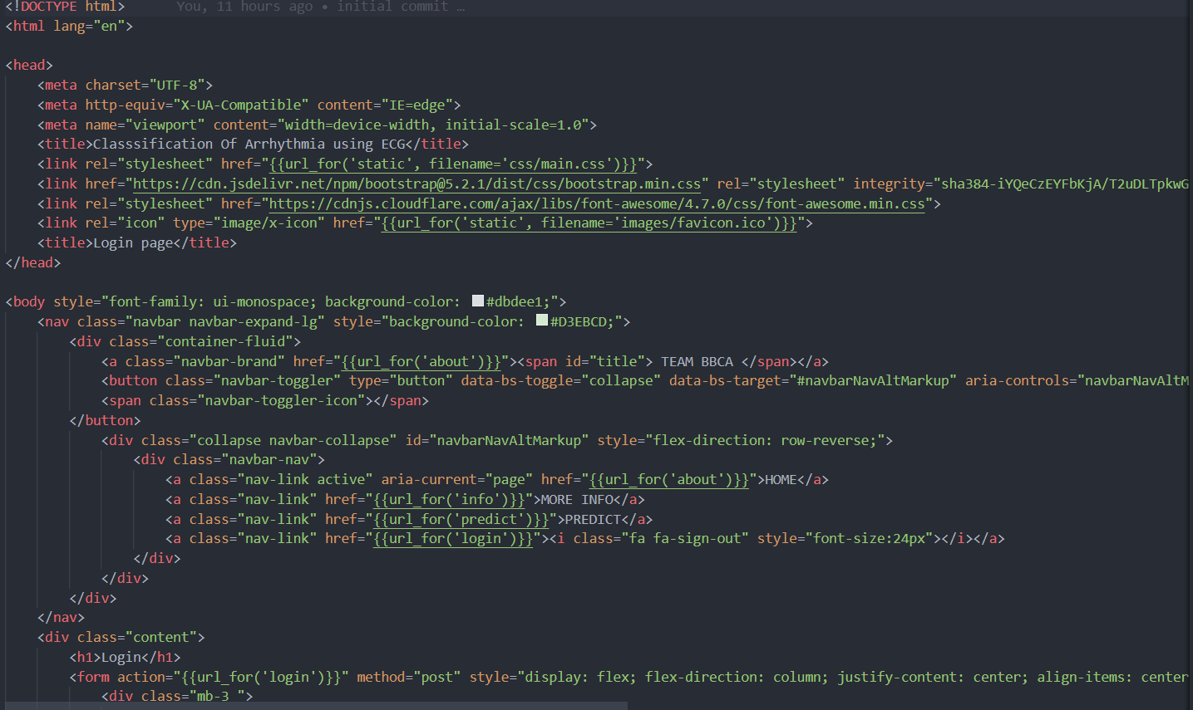

Using ‘login’ URL, users can login into their accounts.

**Feature 9-**

Users can register for the application by entering my email, password, and confirming their password.

**Screenshot:**

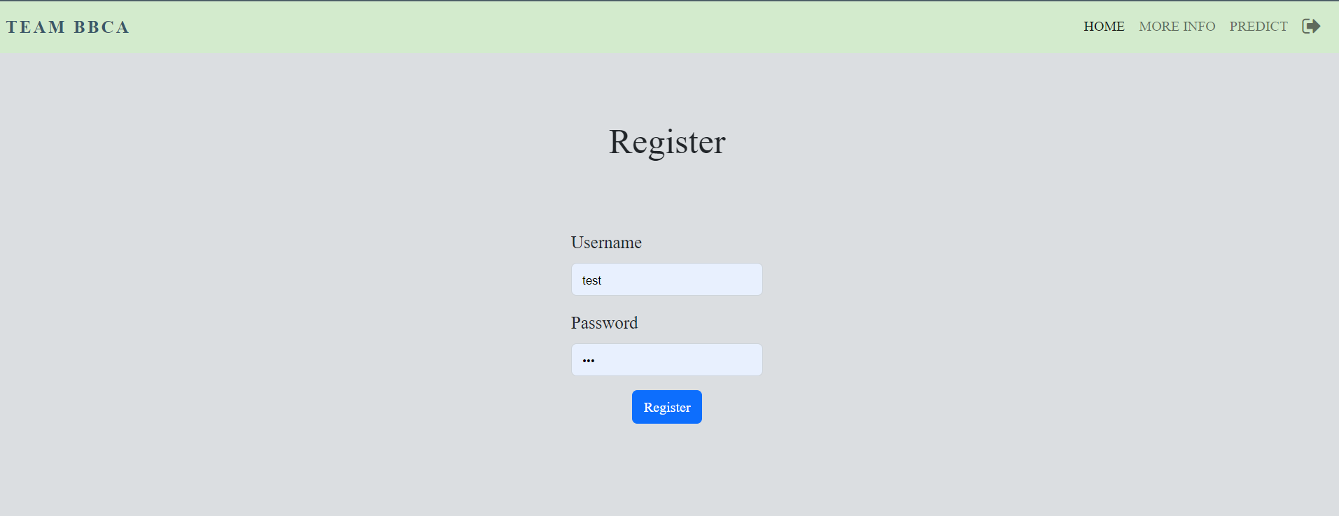

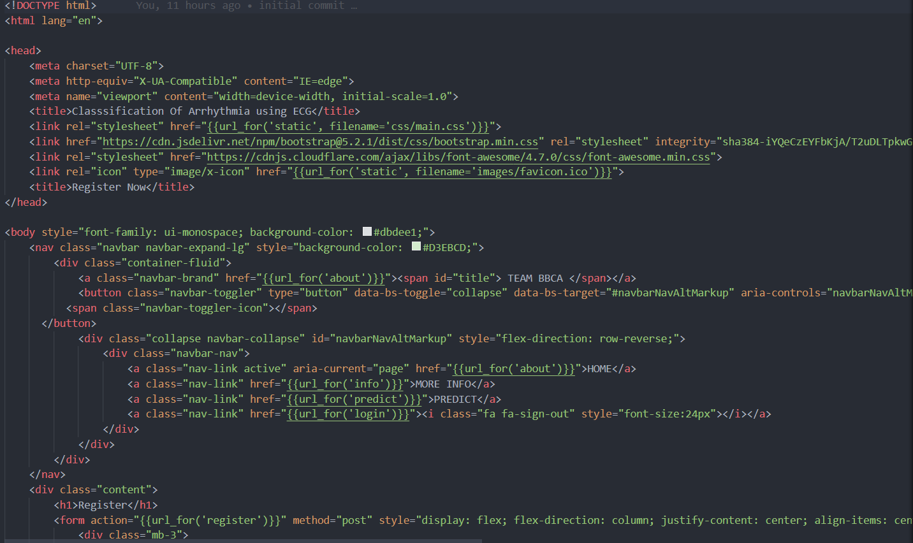

Using ‘register’ URL, the user can register.

**Feature 10-**

The project is accessible on a single website for both mobile, PC users with it being hosted on cloud.

Screenshot:

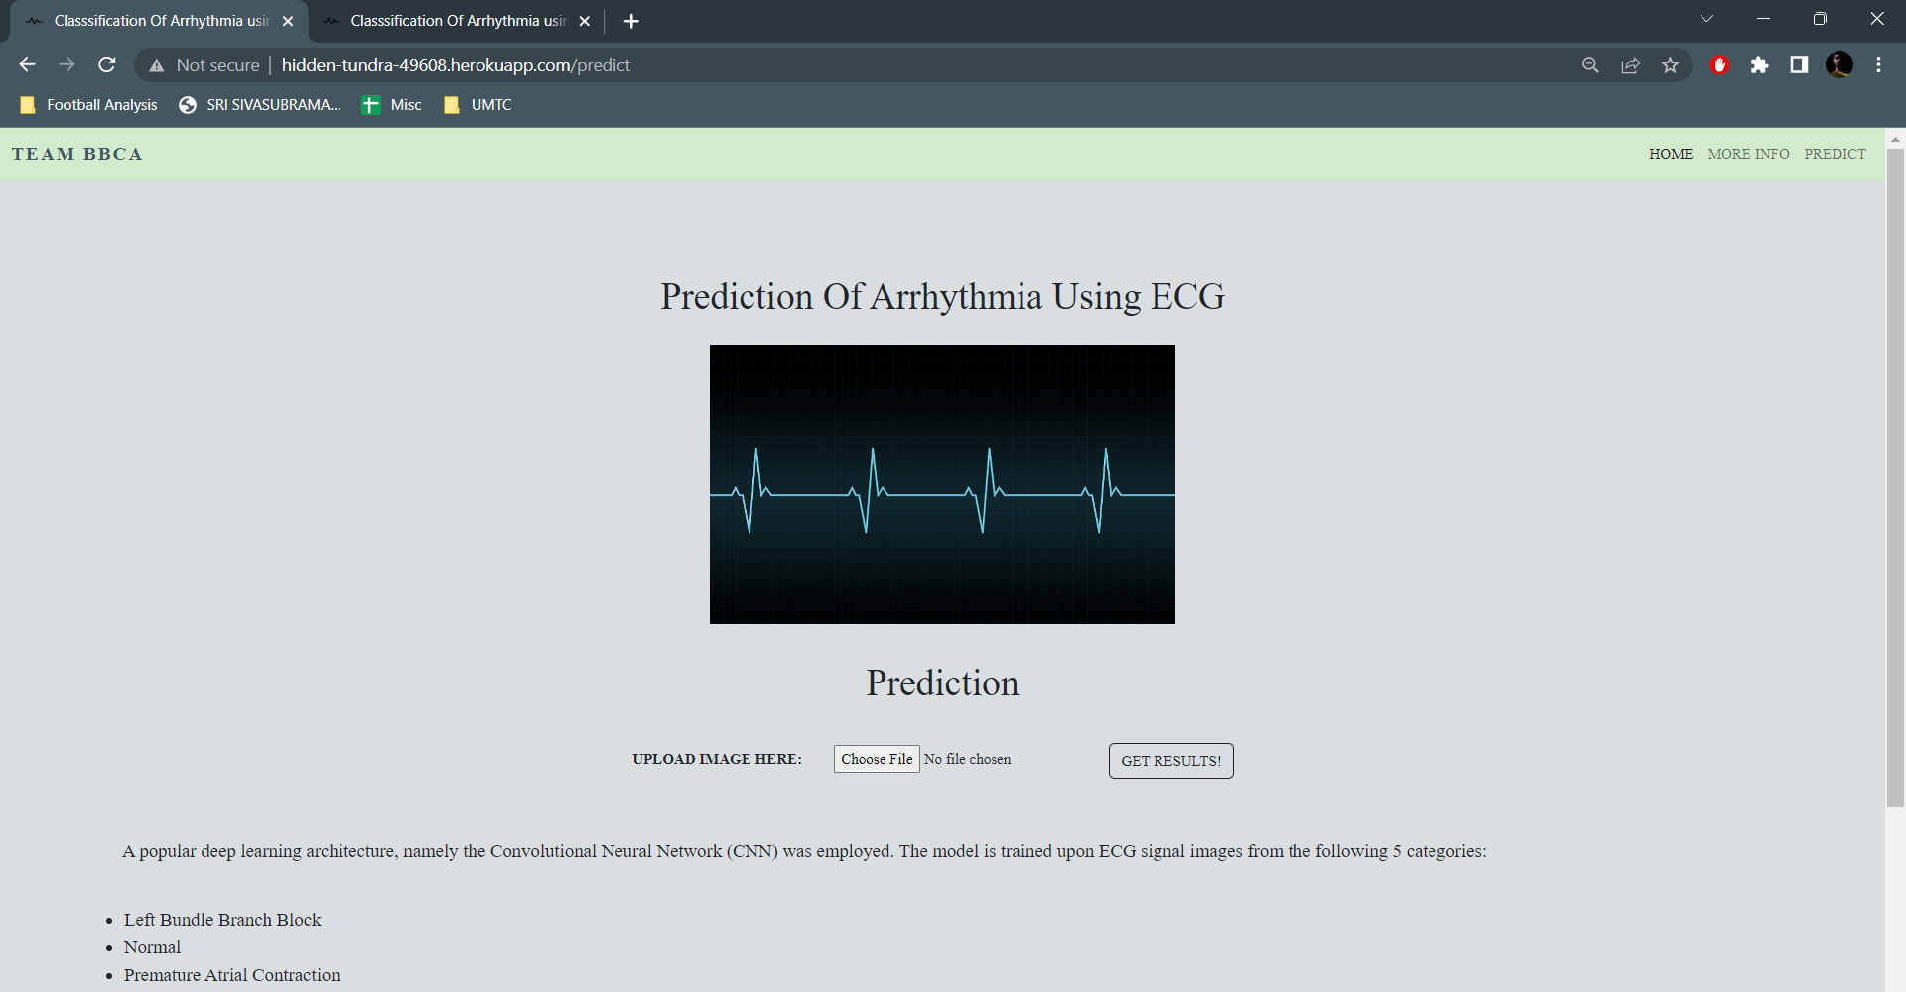



The project was successfully hosted on a cloud platform